AGNUS DEI
“Behold, The Lamb of God!”
John 1:29
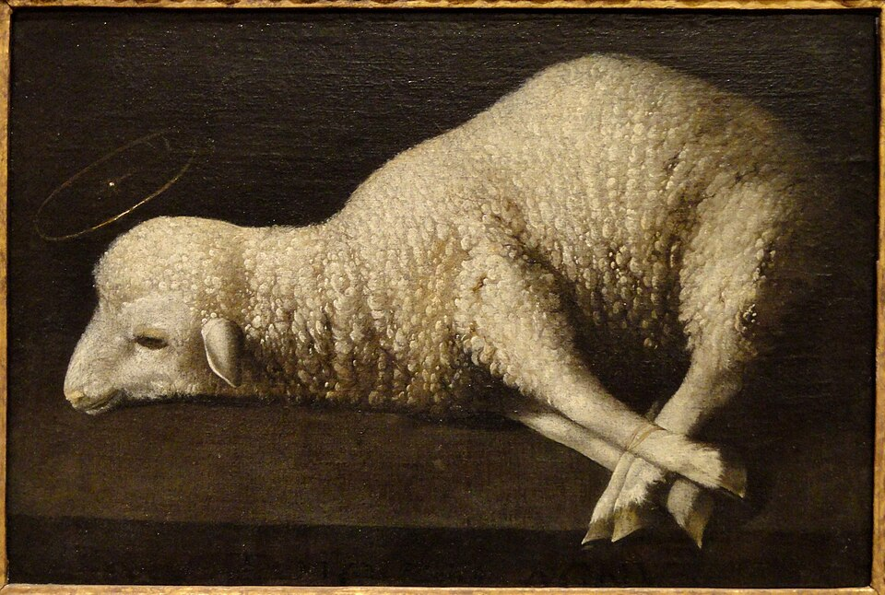
The title Agnus Dei is Latin for “Lamb of God.”
John 1:29: “Behold, the Lamb of God who takes away the sin of the world!”
John uses eight theological titles for Jesus:
- The Word!
- God the One and Only!
- The Lamb of God!
- Rabbi!
- The Son of God!
- The Messiah!
- The King of Israel…and
- The Son of Man!
THE LAMB OF GOD:
- The Lamb of God points to the main reason Jesus came into the world and that was to die for the sins of the world!
- The Lamb of God connects Jesus to the entire Old Testament!
- The Lamb of God unveils the One who is the focus of all the worship and praise of Heaven!
- The Lamb of God reveals the character of God as One who is full of grace and mercy!
- The Lamb of God is the one that brings people to salvation!
THREE KEY ASPECTS of Jesus as THE LAMB of GOD!
- Jesus, as the Lamb of God, is our substitute!

- The concept of substitutionary atonement can be traced all the way back to Genesis chapter 22 when God tested Abraham.
What do we learn about the cross from this foreshadowing of Jesus as the Lamb of God?
- Just as the lamb was sacrificed instead of Isaac, so Jesus was sacrificed instead of us.

- Jesus was and is our sacrifice of atonement!
- Theologians refer to this as vicarious, penal, substitutionary atonement in that Jesus shed his blood for us. He took our place on the cross!
Romans 3:25 says, “God presented him as a sacrifice of atonement, through faith in his blood!’
- In taking our place on the cross, Jesus accomplished two very important things for us:

- He satisfied God’s justice!
- He appeased God’s wrath.
1 Thessalonians 1:10 “Jesus, who rescues us from the coming wrath!”
Romans 5:8 “But God demonstrates his own love for us in this: While we were still sinners, Christ died for us.”
Mark 10:45 “For even the Son of Man did not come to be served, but to serve, and to give his life as a ransom for many!”
Do you know what the greatest threat all of mankind faces? It is the wrath of God!
Revelation 19:15 “He treads the winepress of the fury of the wrath of God Almighty. On his robe and on his thigh, he has this name written:
KING OF KINGS AND LORD OF LORDS!”
The cross of Christ is the most beautiful picture of God’s perfect love and justice coming together in order to save us from His wrath!
- Jesus, as The Lamb of God, literally poured out His blood for us to be cleansed and saved!
1 Peter 1:18-20: “18 For you know that it was not with perishable things such as silver or gold that you were redeemed from the empty way of life handed down to you from your forefathers, 19 but with the precious blood of Christ, a lamb without blemish of defect. 20 He was chosen before the creation of the world but was revealed in these last times for your sake.”

We see all of this foreshadowed in Passover. There is great interconnection between the Old and New Testaments. It has been said that the OT is the NT concealed, and the NT is the OT revealed.
- Passover is the heart of the book of Exodus, and perhaps, the heart of the entire Old Testament.
- Passover was in the mind and heart of God in order to show us his plan to save the world!
Exodus 11: 4-6: The Lord told Moses, “About midnight I will go throughout Egypt. 5 Every firstborn son in Egypt will die, from the firstborn son of Pharoah, who sits on the throne, to the firstborn son of the slave girl, who is at her hand mill, and all the firstborn of the cattle as well. 6 There will be loud wailing throughout Egypt—worse than there has ever been or ever will be again.”
THE PASSOVER!
The Lord said to Moses… 3 “Tell the whole community of Israel to take a lamb for his family…one without defect, and you may take them from the sheep or the goats…
VERSE 6 At twilight you are to slaughter them and 7 take some of the blood and put it on the sides and tops of the doorframes of the houses where you eat the lambs…
VERSE 12 On that same night I will pass through Egypt and strike down every firstborn—both men and animals—and I will bring judgment on all the gods of Egypt. I am the Lord. 13 The blood will be a sign for you on the houses where you are; and when I see the blood, I will pass over you…14 This is a day you are to commemorate; for the generations to come you shall celebrate it as a festival to the Lord—a lasting ordinance.”
Verse 28 “The Israelites did just what the Lord commanded Moses and Aaron. 29 At midnight the Lord struck down all the firstborn in Egypt, from the firstborn of Pharaoh, who sat on the throne, to the firstborn of the prisoner, who was in the dungeon, and the firstborn of all the livestock as well. 30 Pharaoh and all his officials, and all the Egyptians got up during the night, Christianity is a bloody religion.
- the most important Lamb to shed his blood was the Lamb of God who was crucified in the region of Moriah on the very mountain that Abraham named, “The Lord will provide!”
Why does God require a blood sacrifice? FOUR REASONS:
- To show the egregiousness and costliness of sin!
- To show the value of life!
- To provide the only way for us to be reconciled to a holy God.
The word atonement means “at-one-ment,” or becoming “at one” again with God after being separated because of sin. It is reconciliation between enemies brought about by a bloody sacrifice, in this case the life of an innocent lamb or goat.
- The act of sacrifice required not just the death of an animal, but the pouring out of its blood, demonstrating that the totality of its life was being offered in place of the sinner’s life!
Hebrews 9:22 “In fact, the law requires that nearly everything be cleansed with blood, and without the shedding of blood there is no forgiveness!”
In Leviticus 17:11 God lays out his condition for atonement: “For the life of the creature is in the blood, and I have given it to you to make atonement for yourselves on the altar; it is the blood that makes atonement for one’s life.”
This last phrase can also be translated: “It is the blood that makes atonement [in the place of] one’s life.”
THE SUFFERING SERVANT!
Isaiah 53…
5 But he was pierced for our transgressions, he was crushed for our iniquities; the punishment that brought us peace was upon him, and by his wounds we are healed. 6 We all, like sheep, have gone astray, each of us has turned to his own way; and the Lord has laid on him the iniquity of us all…
10 Yet it was the Lord’s will to crush him and cause him to suffer, and though the Lord makes his life a guilt offering, he will see his offspring and prolong his days…
12 because he poured out his life unto death... [and] He bore the sin of many and made intercession for the transgressors.
In John 19:33-34, [When the soldiers] came to Jesus and found that he was already dead, they did not break his legs. Instead, one of the soldiers pierced Jesus’ side with a spear, bringing forth a sudden flow of blood and water.”
At the last supper Jesus says in Matthew 26:28, “This is my blood of the covenant, which is poured out for many for the forgiveness of sins!”
- Jesus, as the Lamb of God, now reigns over all of the universe from the throne of heaven!

- John sees Jesus as the Lamb who was slain. Jesus still bears the scars from His death on the cross.
- He will forever bear these scars as a reminder to all of us once we arrive in heaven that we are there only because of his sacrifice for us.
- This explains why right now in heaven; there is an on-going worship service with songs, hymns of praise and the prayers of the saints.
- The Lamb is seated upon the throne. God the Father is there, however, He is ruling the universe by and through His Son, the Lamb of God, who is worthy of all praise, glory and honor.

Behold! The Lamb of God who takes away the sin of the world!

